23.71: a) Problem 23.70 shows that
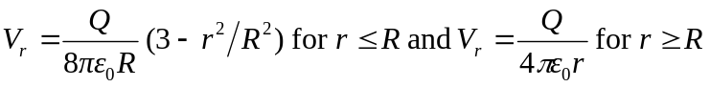
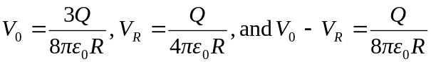
b) If 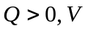 is higher at the center. If 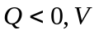 is higher at the surface.

